**Search Longest Word – Module 1**

**MapReduce**

* Data processing layer in Hadoop.
* Processing structured & Unstructured Data in Hadoop.

**Pros**

* Best Performance

**Cons**

* Hard to Extend
* Lack of management tools
* Not suitable for real time processing
* very small community

**Input Directory**

Input directory contains input files that will be processed by MapReduce to find longest word.



In the above screenshot, we can see an input directory (in) contains 2 input files (input.txt, input1.txt).

**Input.txt**

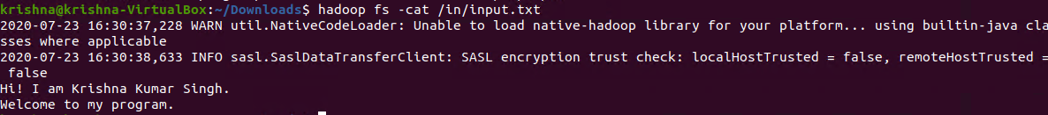

In the above screenshot, we can see the content of the first input file.

**Input1.txt**

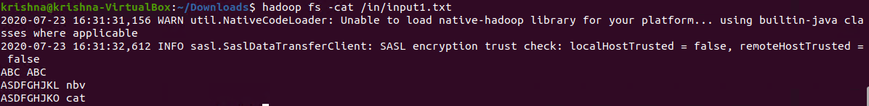

In the above screenshot, we can see the content of the second input file.

**Executing Hadoop Jar**

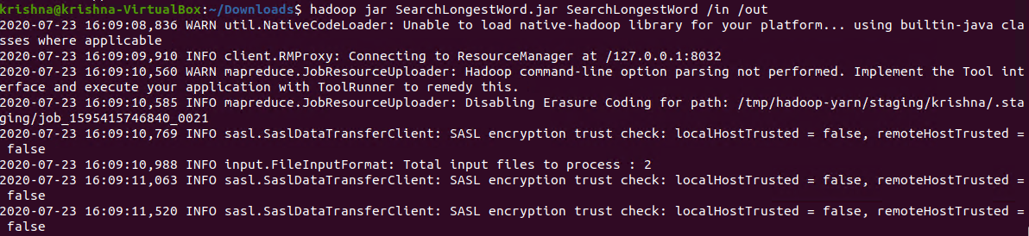

In the above screenshot, we can see the command to find longest word.

**hadoop jar:** This is command used to execute Hadoop jar

**SearchLongestWord.jar:** Hadoop jar file name

**SearchLongestWord:** jar class name contains main().

**/in:** Input directory contains file to process

**/out:** Ouput directory will be created after execution of this command

**Output Directory**

Output directory will be automatically created contains output files.



**Read output file Content:**



In the above screenshot, we can see the output contains key 9 – represent the length of the word & value – maximum length word.

**Test Cases:**

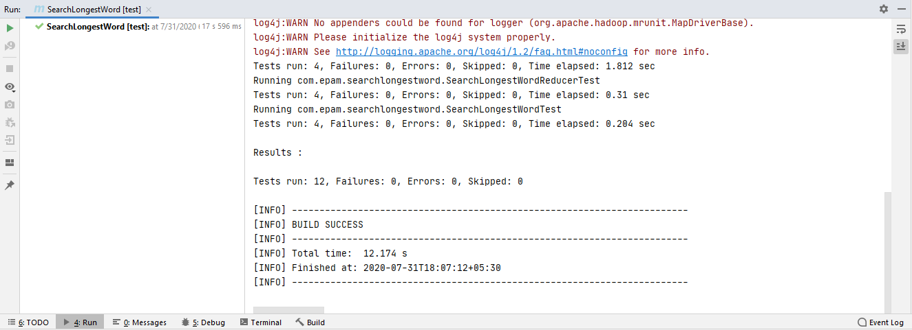

In the above screenshot, we can see that all 12 test cases have passed.